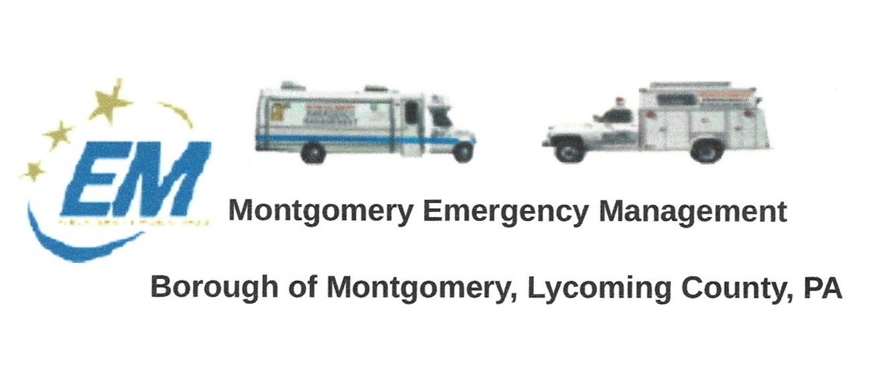
THE NEXT REGULAR MEETING OF THE MONTGOMERY BOROUGH EMERGENCY MANAGEMENT AGENCY WILL BE:
Greg Gruver, EMA Coordinator. 77 East Houston Avenue, Montgomery, PA 17752
Telephone: 570-547-1212 Cell: 570-419-4866 Email: monteman61@gmail.com
Fae Herb, Administrative Assistant. 102 Broad Street, Montgomery, PA 17752
Cell: 570-506-9892 Email: faeherb@aol.com
Meeting Room and Equipment Building: 40 Thomas Avenue, Montgomery, PA 17752
Borough EOC: 570-547-1671 Fire Hall EOC: 570-547-1381
INTERNET WEBSITE: www.montgomeryboroughema.org

THURSDAY, OCTOBER 13, 2022 AT 7 P.M.
REFRESHMENTS PROVIDED BY FAE HERB
Notes from Administrative Assistant, Fae Herb
The month of September gave us a share of wet weather. The 21st annual 9/11 motorcycle ride was a wet ride, but it brought out over 400 riders and the public waving their flags in 6 boroughs as well as townships, letting people know “We Will Never Forget”.
Also at the last minute, volunteers were asked to help out with the Balloonfest held at the Lycoming County Fairgrounds, Hughesville. Dennis Gruver and Dale Brendle helped out on Saturday, September 10.
The EMA is thankful for the donation of a rubber boat, that is now registered and decaled. It is ready for service. Anyone wanting to join the EMA water rescue is asked to get in touch with Greg Gruver.
Age is creeping up on Unit 6-30, it has served the EMA and borough well, but letters are being prepared to send out to local businesses to raise funds to purchase a “newer” truck. The use of the truck is to drive to flood gauges to report to County, plowing, transporting light towers to events, or incidents. Also, helping out distributing in December for Toys For Tots.
Improvements are being made on the Meeting trailer meeting room. A big thanks to our electricians, Ed and Dale. Electrical updates have been done, an air conditioner and ceiling fan to help during those hot months and Ed F. has donated a window that Dale is planning on installing.
The end of October will bring us ghouls and goblins. Trick or Treat hours will be Monday, October 31st, 6:30-8:30. Lions Halloween Parade beginning at Weis Markets moving at 6 p.m. Plans will be discussed at our October EMA meeting for parade.
Stay informed of upcoming weather conditions by EMA member Les Gruver on Montgomery, PA News and Views Facebook page. He generally informs us of bad weather conditions, but it was a pleasant surprise when he informed us of a beautiful weekend a few weeks ago. His advisory has amended my plans. A big thanks to you Les.
Volunteers are always needed in many different positions within the EMA. Come join us the second Thursday of every month, 7 p.m. at the meeting room, 40 Thomas Avenue.

Fae Herb
Administrative Assistant

